Karma Police , Radiohead , 1997
Intro  Am D Em G  Am F Em G  Am D  G C C  Am Bm D  Am D Em  Kar-ma police  G Am  Arrest this man  F Em  He talks in maths  G Am  He buzzes like a fridge  D G C Am Am Bm D  He's like a detuned radi-----o  Am D Em  Kar-ma police  G Am  Arrest this girl  F Em  Her Hitler hairdo  G Am  Is making me feel ill  D G C Am Am Bm D  And we have crashed her paar-ty  C D G Gb  This is what you'll get  C D G Gb  his is what you'll get  C D G  This is what you'll get  Bm C C Bm D  When you mess with us  Am D Em  Karma police  G Am  I've given all I can  F Em  It's not enough  G Am  I've given all I can  D G C Am Am Bm D  But we're still on the pay-------roll | C D G Gb  This is what you'll get  C D G Gb  his is what you'll get  C D G  This is what you'll get  Bm C C Bm D  When you mess with us  X2  Bm D G  And For a minute there  D G D E7  I lost myself, I lost myself  Bm D G  Ad for a minute there  D G D E7  I lost myself, I lost myself  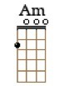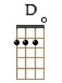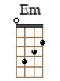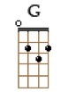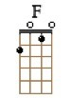  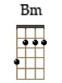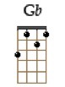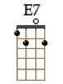  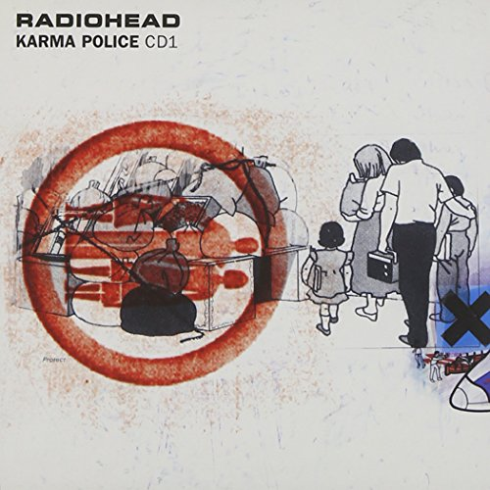  Strum intro : B. BhB  Puis B B sur chaque accord ?

